**Name:** Shivam Verma

**Course:** B.Sc. (H) Computer Science

**Semester:** 5th

**College Roll No.:** 19HCS4048

**Q3. Create a dataframe having at least 3 columns and 50 rows to store numeric data generated using a random function. Replace 10% of the values by null values whose index positions are generated using random function.**

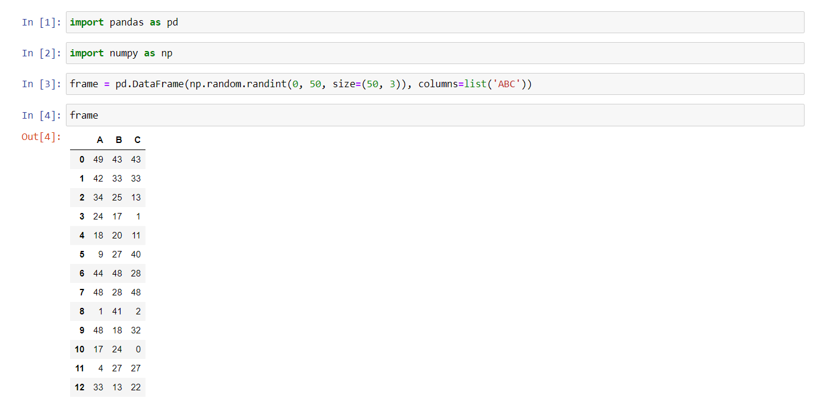

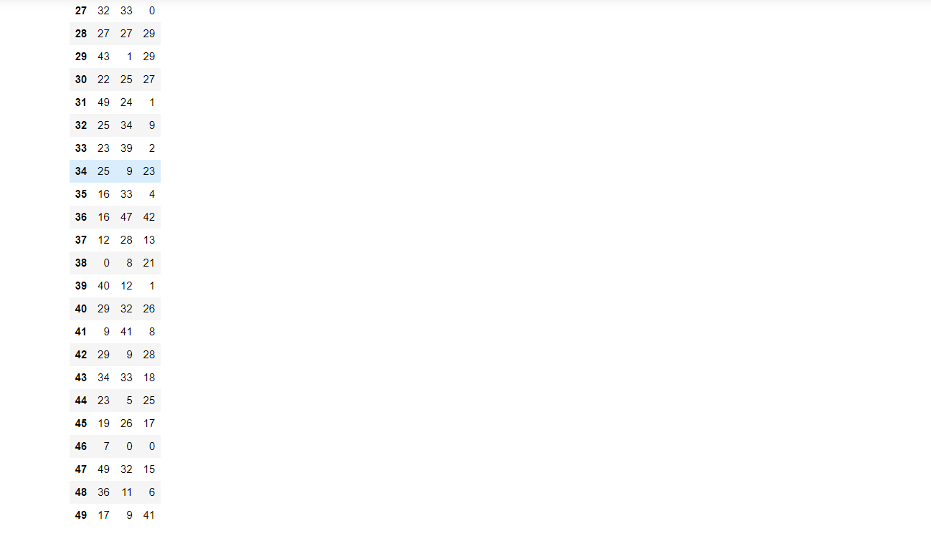

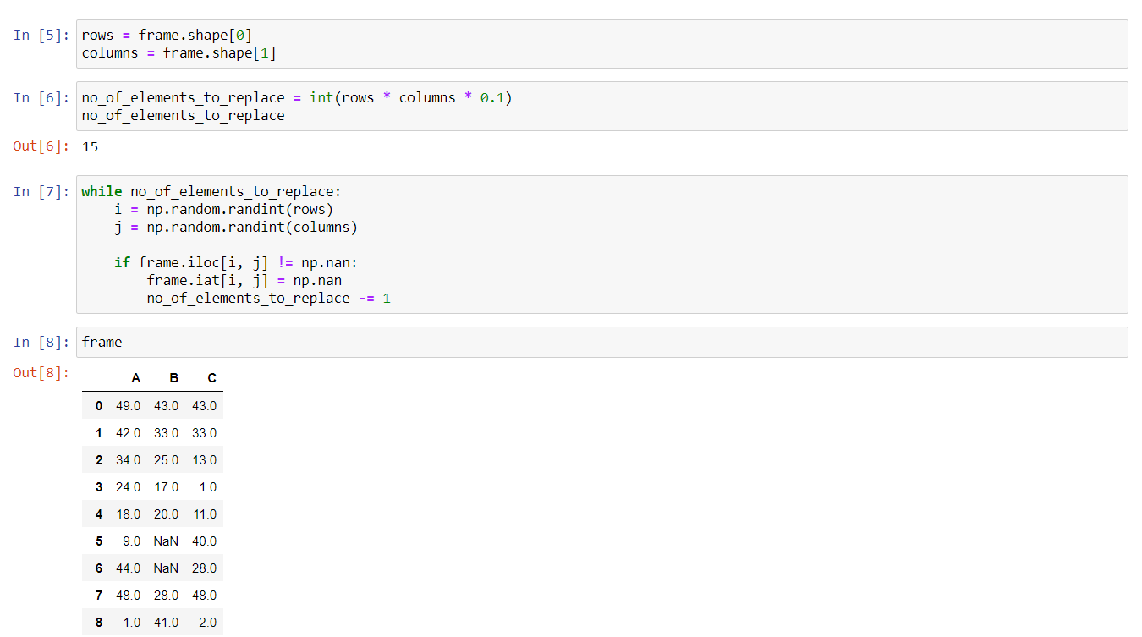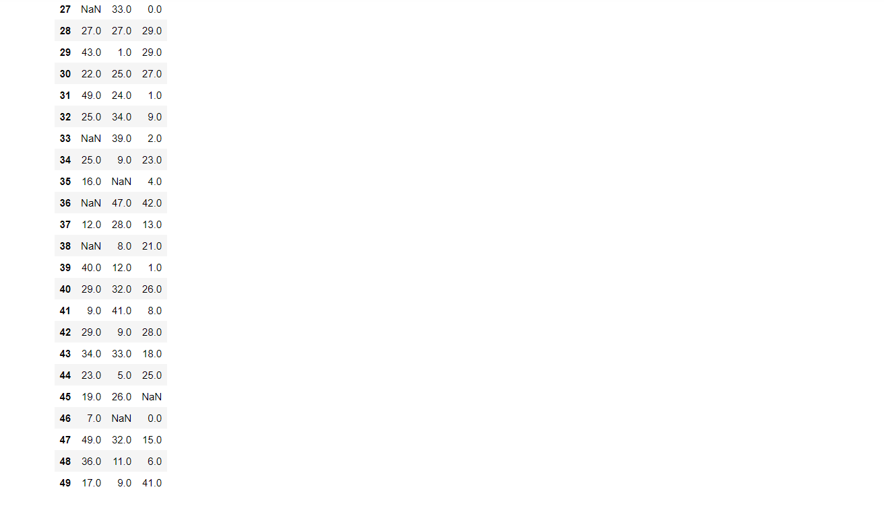

**Do the following:**

1. **Identify and count missing values in a dataframe.**

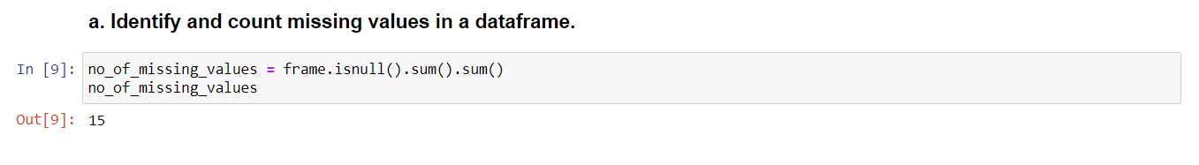

1. **Drop the column having more than 5 null values.**

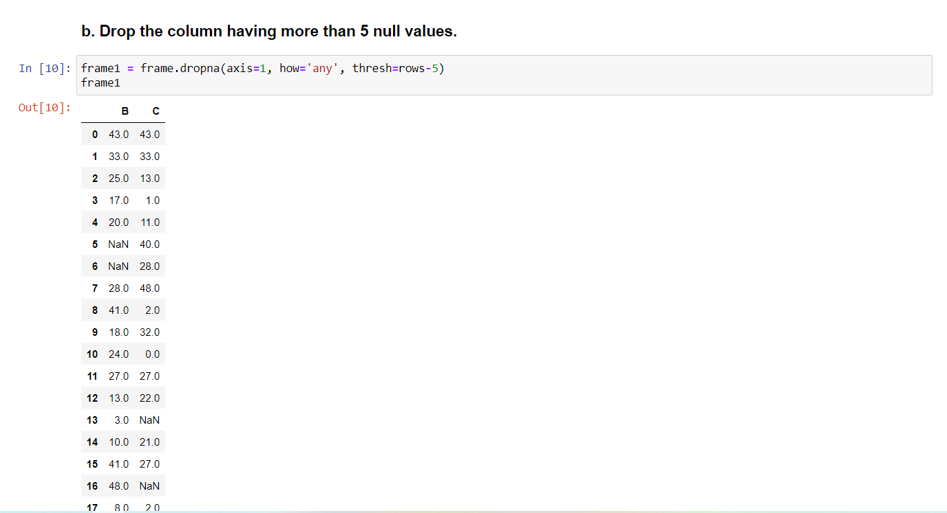

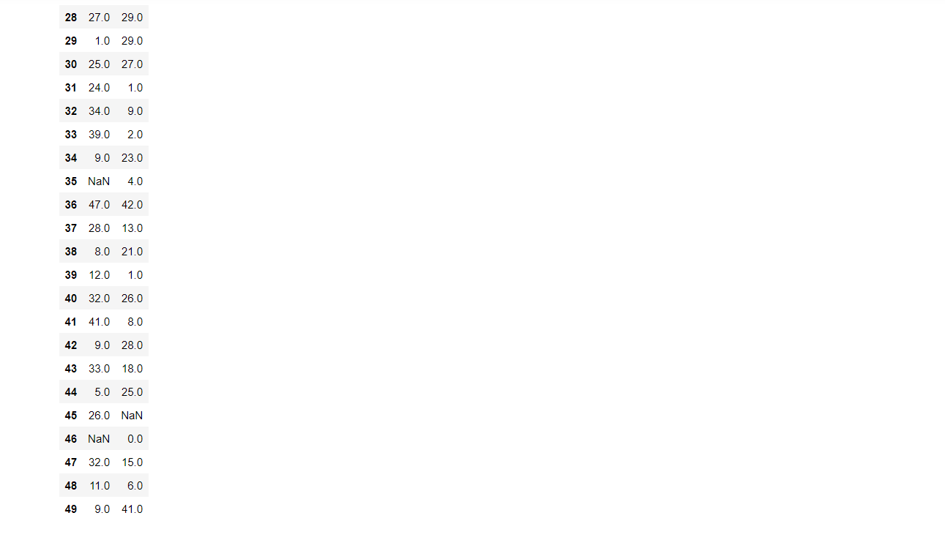

1. **Identify the row label having maximum of the sum of all values in a row and drop that row.**

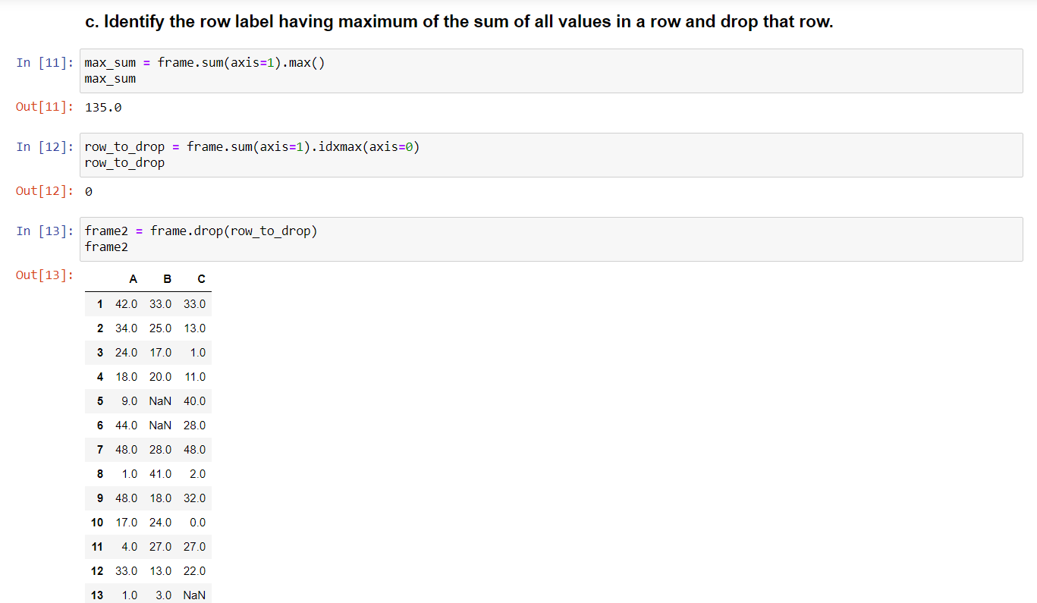

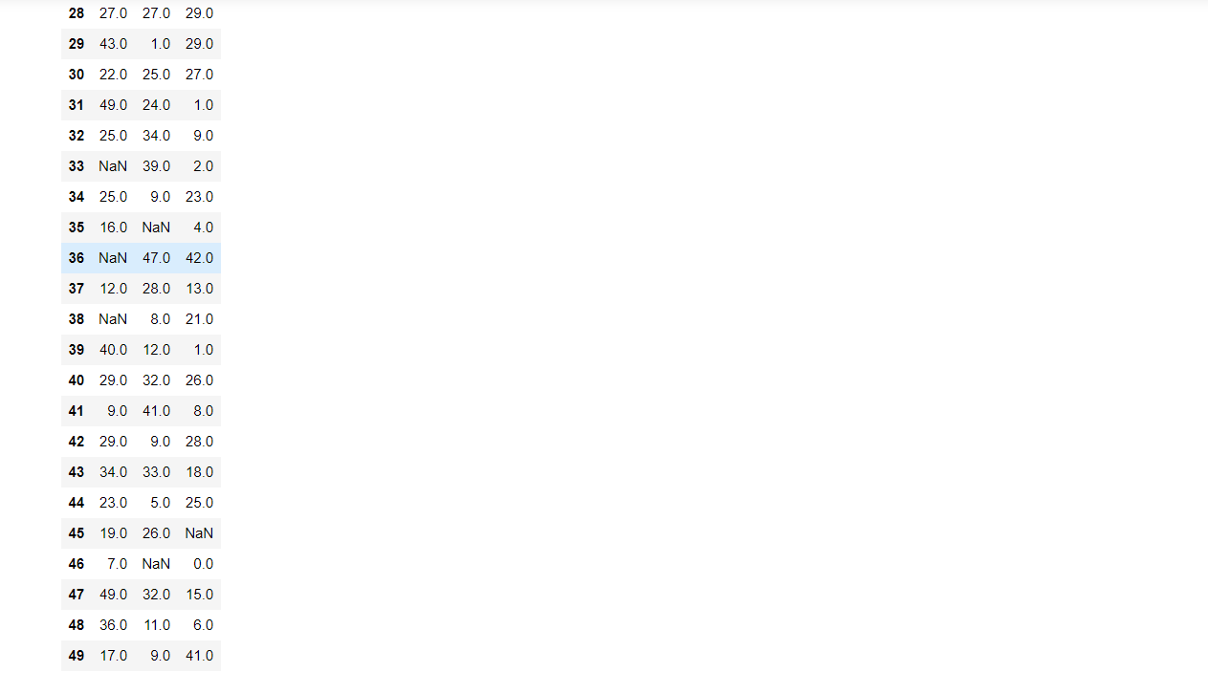

1. **Sort the dataframe on the basis of the first column.**

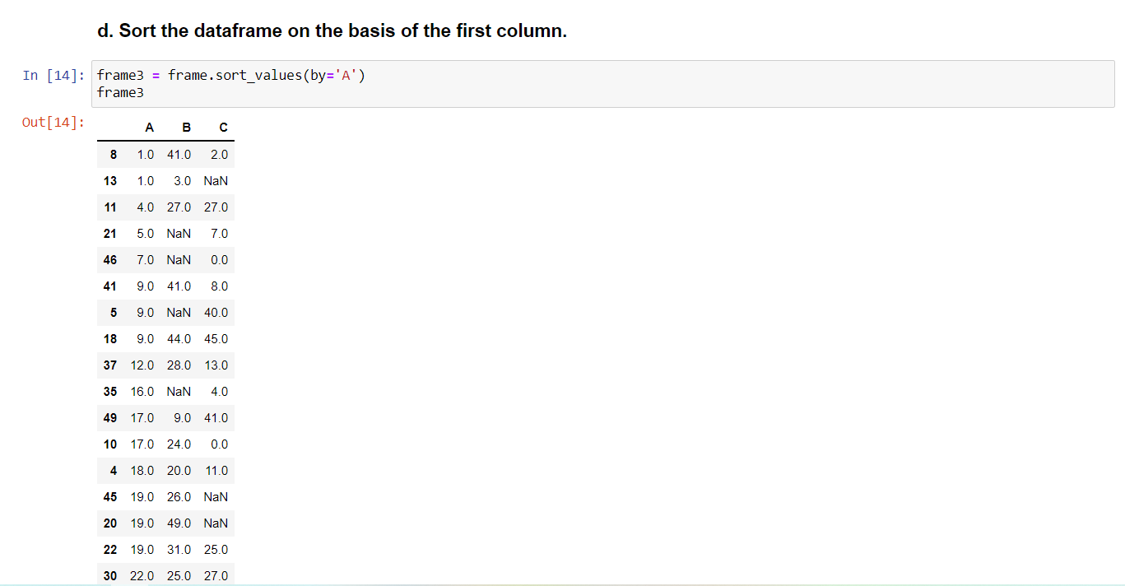

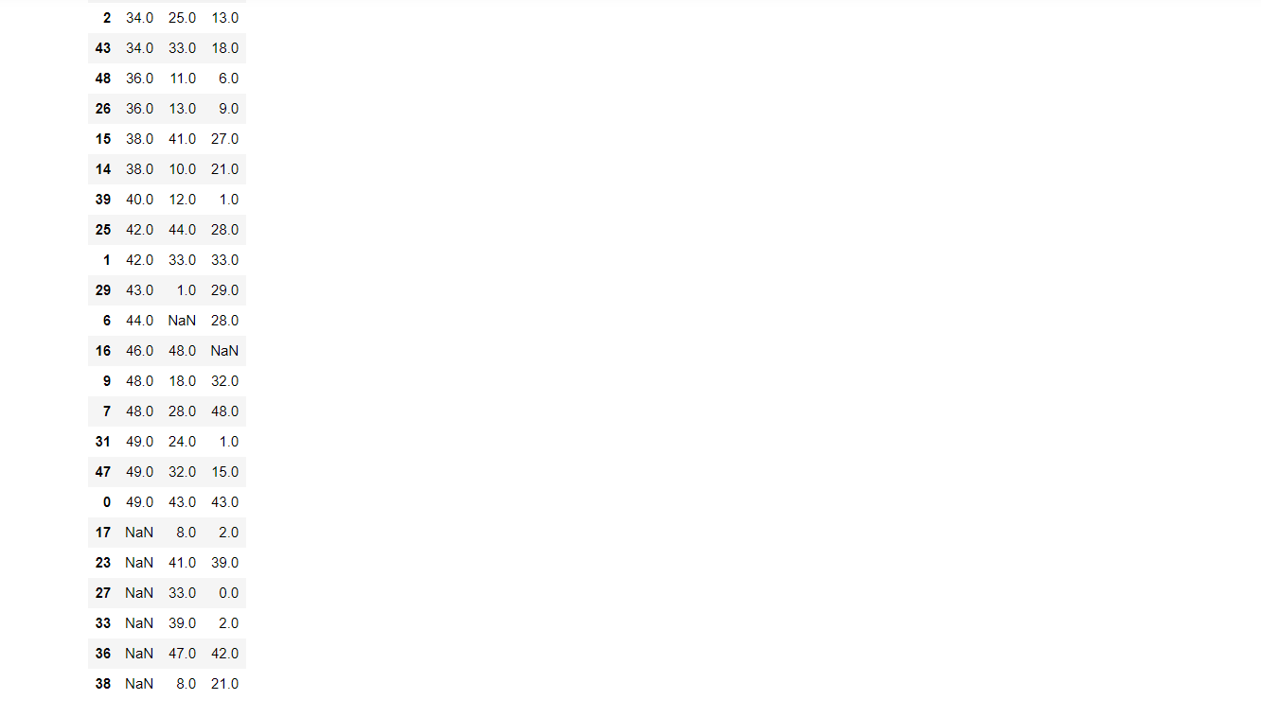

1. **Remove all duplicates from the first column.**

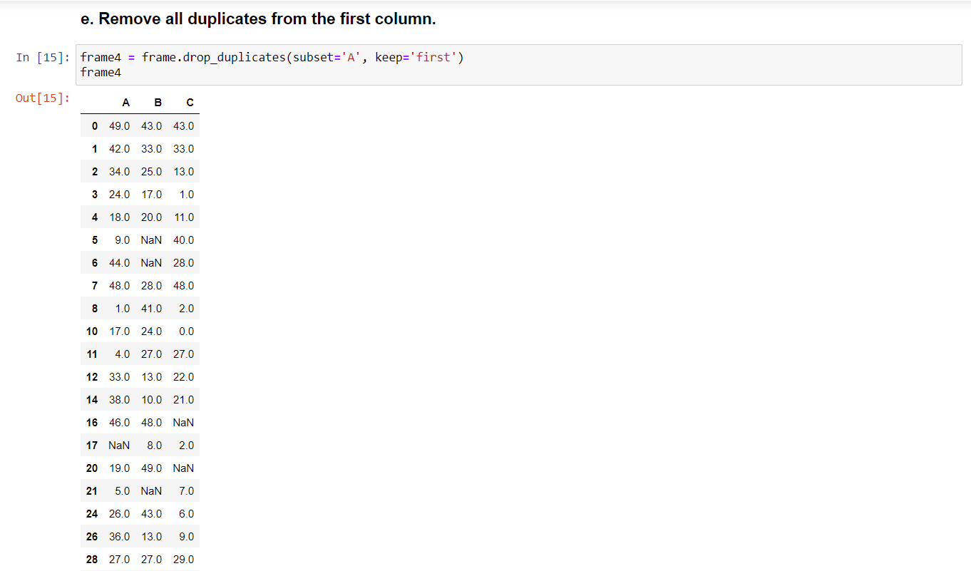

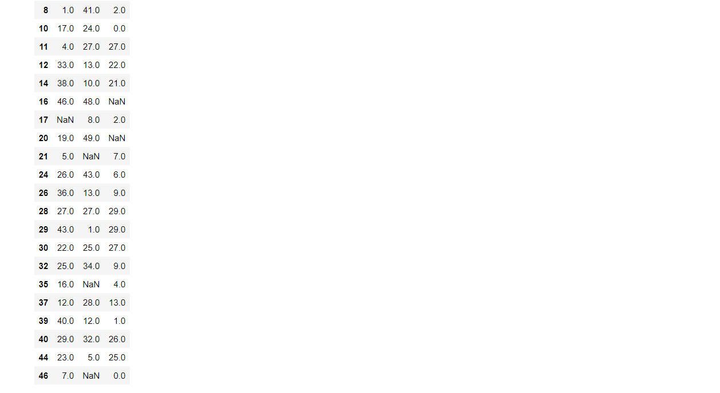

1. **Find the correlation between first and second column and covariance between second and third column.**

